AEM Headless CMS: Content Fragment and Model
X https://www.hcltech.com/blogs/understanding-how-adobe-aem-delivers-headless-content
X https://one-inside.com/aem-content-fragments-vs-experience-fragments
Graph QL
Get started with AEM Headless - GraphQL | Adobe Experience Manager

Editable templates:
X https://www.hcltech.com/blogs/understanding-adobe-aem-editable-templates#page-main-content
https://experienceleague.adobe.com/docs/experience-manager-64/developing/platform/templates/templates.html?lang=en
https://www.argildx.com/technology/how-to-create-and-enable-dynamic-templates-in-aem/ ->Best
Template policies:
https://myaemlearnings.blogspot.com/2018/03/policies-in-editable-templates.html

MSM -> IMP
https://aem4beginner.blogspot.com/multi-site-manager-interview-questions -> CQ5
https://experienceleague.adobe.com/docs/experience-manager-64/administering/introduction/msm.html?lang=en

MULTIFILED:
ui/api/jcr_root/libs/granite/ui/components/coral/foundation/form/multifield/index.html

Workflow:
X https://aem4beginner.blogspot.com/aem-workflows-interview-questions
https://experienceleague.adobe.com/docs/experience-manager-64/developing/extending-aem/extending-workflows/workflows.html?lang=en

Apache Sling Model:
https://aem4beginner.blogspot.com/apache-sling-interview-questions

Sling Model with Sightly
http://www.aemcq5tutorials.com/tutorials/adobe-aem-cq5-tutorials/sling-model-sightly-aem/

Sling Schedulers:
https://aem4beginner.blogspot.com/scheduler-interview-questions

Sling Servlets:
https://aem4beginner.blogspot.com/aem-servlet-interview-question

Content Fragment:
https://www.netsolutions.com/insights/content-fragments-in-aem/
https://experienceleague.adobe.com/docs/experience-manager-learn/sites/content-fragments/content-fragments-feature-video-use.html?lang=en
https://experienceleague.adobe.com/docs/experience-manager-learn/sites/content-fragments/content-fragments-delivery-feature-video-use.html?lang=en

Experience Fragment:
https://experienceleague.adobe.com/docs/experience-manager-learn/sites/experience-fragments/experience-fragments-feature-video-use.html?lang=en
https://experienceleague.adobe.com/docs/experience-manager-learn/sites/experience-fragments/experience-fragments-social-technical-video-setup.html?lang=en

Content Exporter
https://experienceleague.adobe.com/docs/experience-manager-64/developing/components/json-exporter.html?lang=en

DAM[Digital Asset Manager]
https://experienceleague.adobe.com/docs/experience-manager-65/assets/assets.html?lang=en

Resource Resolver:
https://one-inside.com/aem6-resourceresolver-access-in-services [crx/explorer/index.jsp]
Service Users Mapper AEM – <AEM Hints/>
https://aem4beginner.blogspot.com/how-to-get-resourceresolver-from

Resources in AEM
https://blogs.perficient.com/2021/05/19/understanding-aem-resources-in-10-minutes/

Style System [IMP]
https://experienceleague.adobe.com/docs/experience-manager-65/authoring/siteandpage/style-system.html?lang=en

Apache Sling Eventing
Apache Sling Job Handling
https://www.linkedin.com/pulse/aem-how-write-sling-jobs-aem-veena-vikraman

OSGI Configuration (Apache sling)
https://aem.redquark.org/2018/10/day-12-creating-your-custom-osgi.html

Difference between OSGi Components and Services
https://stackoverflow.com/questions/8886430/what-is-the-difference-between-osgi-components-and-services
https://techiearchive.blogspot.com/2018/03/difference-between-osgi-service-and.html

JAR vs bundle
http://konigsberg.blogspot.com/2009/04/difference-between-jar-and-bundle.html

Dialog with Data source
https://aem.redquark.org/2018/10/day-18-working-with-granite-datasources.html
http://www.sgaemsolutions.com/2019/01/dynamically-populate-drop-down-values.html

Differences Between var and let
https://www.javascripttutorial.net/es6/difference-between-var-and-let/

WCMUsePojo Best Practice use Model. [Not recommended after 6.2]
https://aem4beginner.blogspot.com/sling-models-vs-wcm-use-pojo

AEM API [VIMP]
https://experienceleague.adobe.com/docs/experience-manager-learn/foundation/development/understand-java-api-best-practices.html?lang=en

Error Handling in AEM.
https://medium.com/tech-learnings/efficient-error-handing-in-aem-adobe-experience-manager-9c8519008179
https://experienceleague.adobe.com/docs/experience-manager-64/developing/platform/customizing-errorhandler-pages.html?lang=en
http://www.aemcq5tutorials.com/tutorials/adobe-aem-cq5-tutorials/custom-error-pages-acs-commons-errorhandler

SSO:
https://experienceleague.adobe.com/docs/experience-manager-65/deploying/configuring/single-sign-on.html?lang=en
AEM REST API
https://experienceleague.adobe.com/docs/experience-manager-screens/user-guide/developing/rest-api.html?lang=en

How to make API secure:
https://experienceleague.adobe.com/docs/experience-manager-64/administering/security/security-checklist.html?lang=en

CDN [Content Delivery Network] to optimise caching [IMP]
https://helpx.adobe.com/in/experience-manager/kb/optimizing-aem-site-caches.html

If you have 10000 assets into the folder and I need to extra 300 users from the Assets what is the logic which get lesser memory.
- Use indexing and get results a move those records only.[Apache Solr]
- Property Index: One of the most used by developers to be able to filter queries by specific properties. Index is stored in the repository itself.
- Lucene Index: This supports full-text indexing. Widely used on AEM projects and stored as part of the AEM repository.
- Traversal Index: This is used if no other indexer is available. This means that the content is not indexed, and content nodes are traversed to find matches to the query.
How to prevent on component to be cached, while you’re caching the whole page into dispatcher?
- Using SDI
https://www.aemquickstart.in/2016/12/sling-dynamic-include.html
https://experienceleague.adobe.com/docs/experience-manager-learn/foundation/development/set-up-sling-dynamic-include.html?lang=en

IF Change is not replicated to the publisher in aem for some browser
- Check Replication agent
Day 15 - Eventing In AEM | Red Quark [Replication]
How to pass data from one workflow step to another in AEM.
Day 12 - AEM Workflows (Part I) | Red Quark
Day 13 - AEM Workflows (Part II) | Red Quark
Day 14 - AEM Workflows (Part III) | Red Quark [MetadataMap]

Event handler vs event listener aem:
Not Working https://aem4beginner.blogspot.com/eventing-in-aem

Error Handling In AEM
https://experienceleague.adobe.com/docs/experience-manager-64/developing/platform/customizing-errorhandler-pages.html?lang=en

https://www.youtube.com/watch?v=w4P9T_miX8Q&t=62s

STROE credentials in encrypted format.
Crypto Support in AEM | Encrypting Plain Text, Decrypting Protective Text

IMPORT HUGE DATA in AEMg
https://adobe-consulting-services.github.io/acs-aem-commons/features/mcp-tools/asset-ingestion/index.html

Dependencies and Embed
https://khakiout.wordpress.com/2016/02/23/aem-clientlibs-difference-between-dependencies-and-embed

CUG
https://experienceleague.adobe.com/docs/experience-manager-learn/assets/advanced/closed-user-groups.html?lang=en
https://experienceleague.adobe.com/docs/experience-manager-65/administering/security/cug.html?lang=en

OAK Seach and Solr
https://blog.3sharecorp.com/aem-search-vs.-solr-search
AEM Search VS. Solr Search
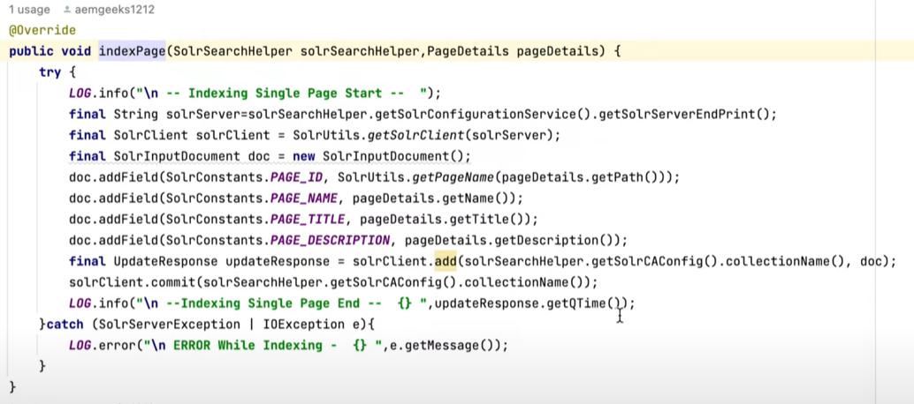
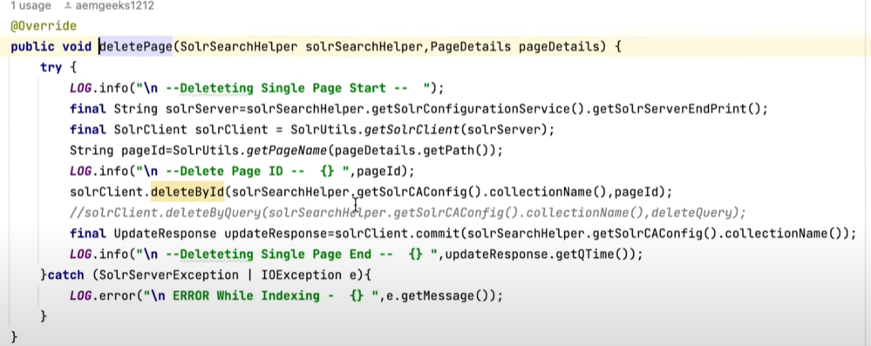

How URL Resoluation is working in AEM
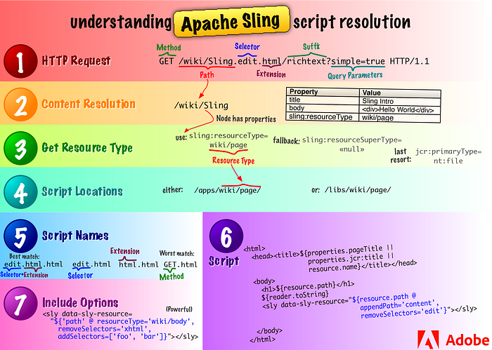
AEM Upgrade/ Migration
Upgrading to Adobe Experience Manager 6.5 | Adobe Experience Manager
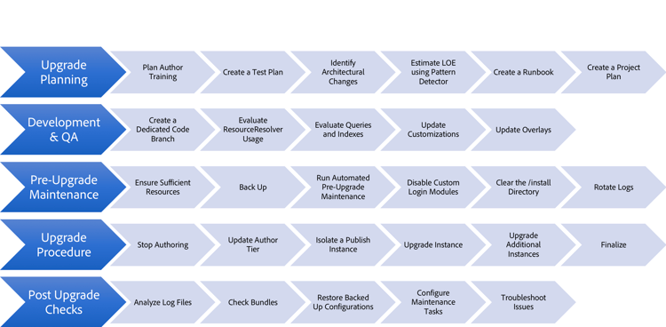

cq:editConfig: https://aem4beginner.blogspot.com/all-about-cqeditconfig
Contains the child node, or list of child nodes, to hide.
sling:hideChildren

Sling Resource Merger, Override and Overlay
https://aemvardhan.wordpress.com/2017/02/22/understand-aem-sling-resource-merger-override-and-overlay-concepts/

sitemap component - list of children
https://www.aemquickstart.in/2015/11/sitemaps-for-adobe-cq-site.html

How query builder works?
http://www.aemcq5tutorials.com/tutorials/adobe-aem-cq5-tutorials/aem-query-builder/ [IMP- Complete Info]

JCR and sling API which one is best
https://myprogressivelearning.wordpress.com/2016/01/23/aem-sling-api-vs-jcr-api/

Ondeply Script
https://adobe-consulting-services.github.io/acs-aem-commons/features/on-deploy-scripts/index.html
https://www.argildx.com/technology/on-deploy-scripts-an-acs-aem-commons-utility/
https://www.argildx.com/technology/

Whiteboard Pattern:
https://www.theserverside.com/news/1363820/The-Whiteboard-Pattern-for-OSGi
[✔] Whiteboard Pattern: Solved: Schedulers in AEM - Adobe Experience League Community - 609386
Design Patterns in Java - GeeksforGeeks

Delegation Pattern for Sling Models
https://aem4beginner.blogspot.com/delegation-pattern-for-sling-models

LEARNING TOPICS
AKAMAI
https://aemcorner.com/aem-akamai-integration/
https://aem4beginner.blogspot.com/search/label/Akamai

IMPORTANT TOPICS IN DETAIL
[Sling ,JCR ,OSGI ,AEM] - > Must in detail.
https://sling.apache.org/documentation/getting-started.html
http://jackrabbit.apache.org/jcr/getting-started-with-apache-jackrabbit.html
https://docs.osgi.org/specification/

OAK API -> READ AFTR
https://experienceleague.adobe.com/docs/experience-manager-65/deploying/introduction/platform.html

Scenarios Based Interview Questions
https://hashimkhan.in/aem-adobecq5-interview-questions/scenarios-based/

https://www.aemquickstart.in/2016/12/configure-dispatcher-for-aem.html ->Good
Setting UP Dispatcher:
http://www.aemcq5tutorials.com/tutorials/set-up-dispatcher-in-aem [SETUP]
Configure AEM Dispatcher | Adobe Experience Manager
https://experienceleague.adobe.com/docs/experience-manager-dispatcher/using/configuring/dispatcher-domains.html?lang=en
https://blogs.perficient.com/2019/01/10/mastering-aem-dispatcher-part-7-securing-the-dispatcher/
https://aem4beginner.blogspot.com/dispatcher-interview-questions [INTERVIEW Questions]

Core Components in AEM [Read in Detail]
https://experienceleague.adobe.com/docs/experience-manager-core-components/using/introduction.html?lang=en

Adaptive Form
https://experienceleague.adobe.com/docs/experience-manager-65/forms/adaptive-forms-basic-authoring/creating-adaptive-form.html?lang=en

How To generate Pdf in AEM
http://experience-aem.blogspot.com/2019/06/aem-65-workflow-step-to-generate-pdf-of-sites-page-during-activation.html

Apache Lucene and Solr | OAK Seach and Solr [IMP]
https://helpx.adobe.com/experience-manager/using/aem_solr64.html [Practical]

AEM As cloud Service.
https://one-inside.com/aem-cloud-service/

6.5 Features
https://www.netsolutions.com/insights/top-adobe-experience-manager-6-5-features/

rewrite rules
dialog validation
embed a->b b->c is possible
servlet through selector and extension
resource type servlet can be called through JS -> Yes
difference b/w overlay and override
how to pass values from one process step to other process step [Workflow]
how to check content path is exist or not

Prakash
editable template store / nodes /policies / component level(allow)
temp level (client libs) -> Add using Page properties of template
client libs, servlets
OSGi configuration, schedulers
workflow process step
run modes
why OSGi (factory configuration)
OSGI life cycle [ACTIVE, STOPPING, STARTING, RESOLVED, INSTALLED, UNINSTALLED]
component overlay (inheritance) override
dispatcher Virtual host
sling models annotation
slightly list repeat
sling resource merger
sling dynamics include (dispatcher)
query builder
service users
node API JCR API
how to use 2 same services in AEM @Target @ServiceRanking @Filter
slingallmethod and slingsafemethod

active and resolved service based on environment
multiple implementations of service -> @serviceRanking -> Target -> Filter
dispatcher
performance improves
search result accuracy

